Objectives:

* Inheritance, super class, sub class, images, setting width and height of frames
* **5 class exercises on this document each worth 20%**

**Project #1**

**Challenge Exercise #1:** Convert the Test Score App into a GUI application, create a class and name it **GradesGUI** and type in the following below:

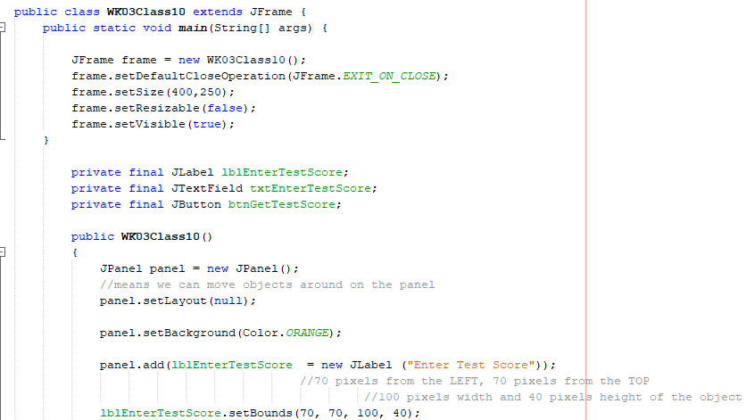 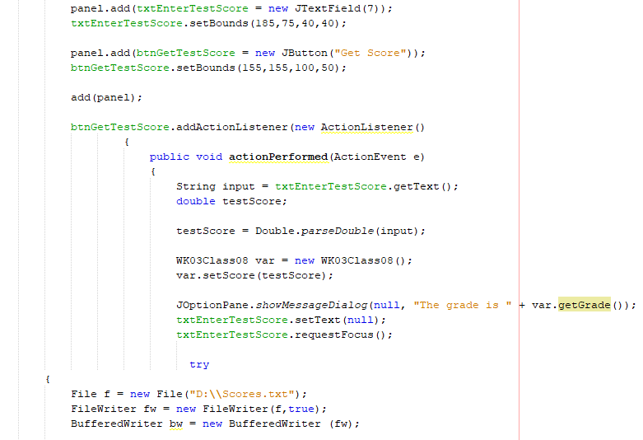

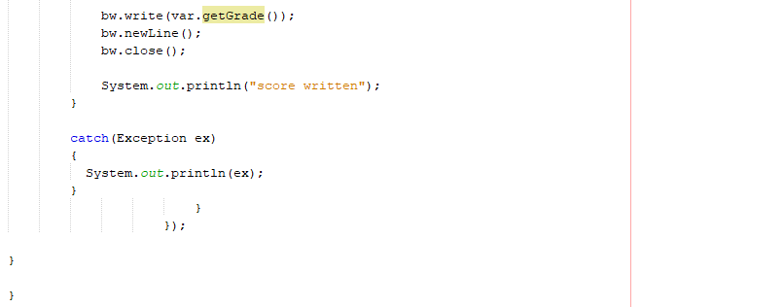

**Print screen the GradesGUI application with code below here.**

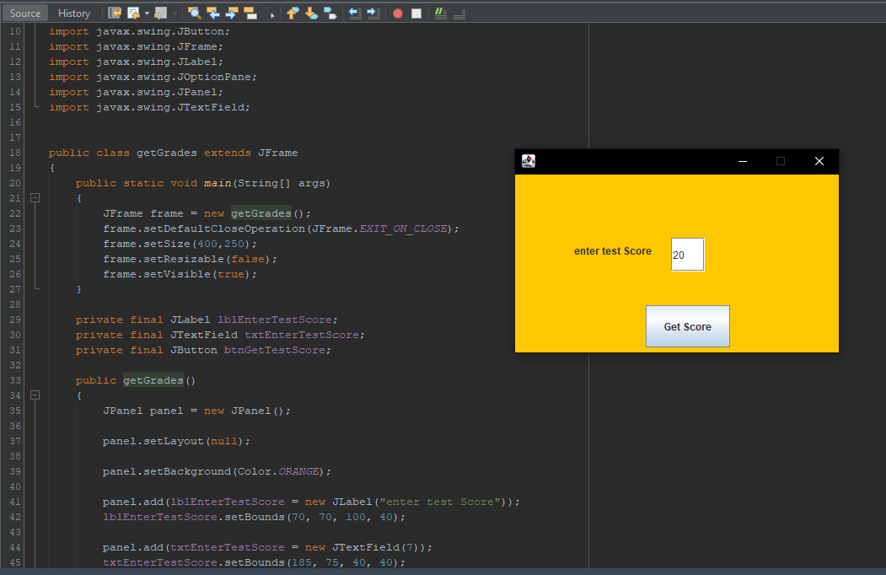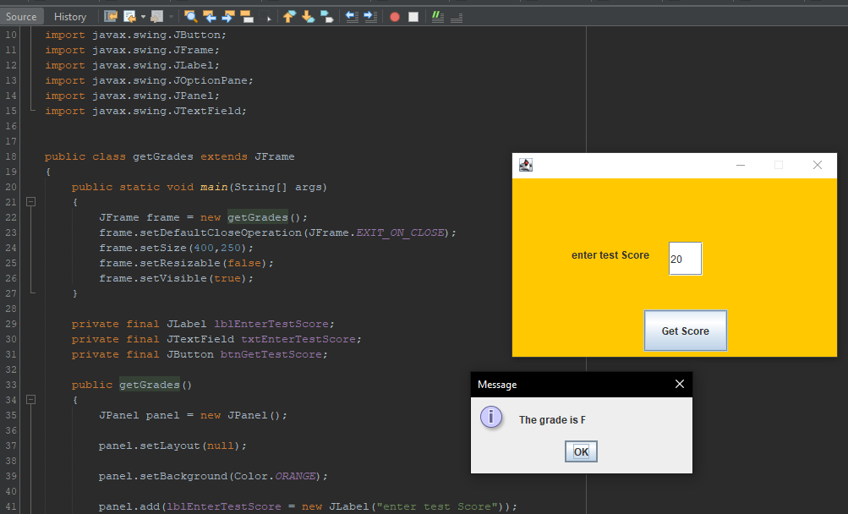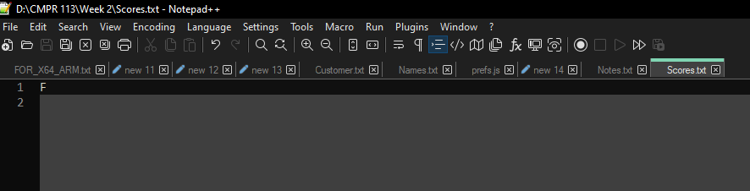

**Project #2**

Create a class **Questions** and type in the following code, this example will return the score. Here we are extending from the class Grades to retrieve the setScore method

Switch back to the RunGrades class and add call the Questions class after the //-----------------

**Challenge Exercise #2:**

Create a class where it will capture and transfer scores instead of grade letters. Enter 5 scores and using the reader *sum* and *average* the scores into a *JOptionPane.showMessageDialog* method.

**Print screen the running application with code below here**

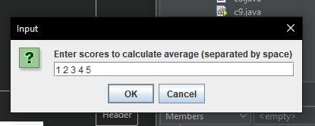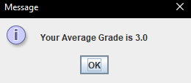

**Sample output**

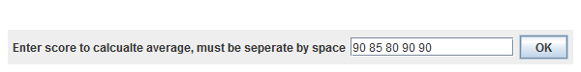

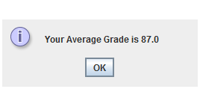

Here is the code

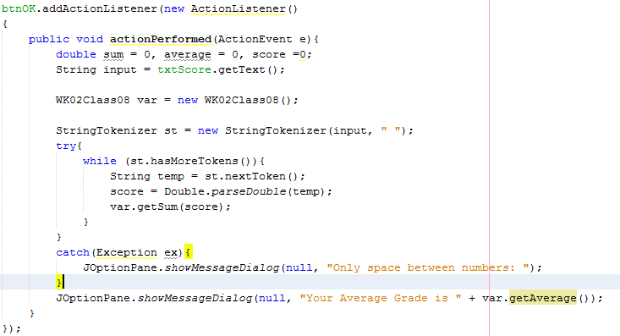

The java.util.StringTokenizer class allows you to **break** a String into tokens. It is simple way to break a String. It is a legacy class of Java.

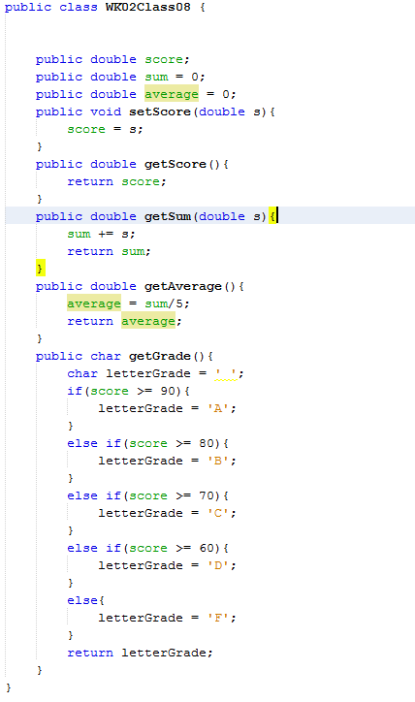

**Challenge Exercise #3:**

Create a class and build a GUI application for the Exam App. Be sure to have a label, text field and a button object that will transfer the data into a text file.

**Print screen the running application with code below here**

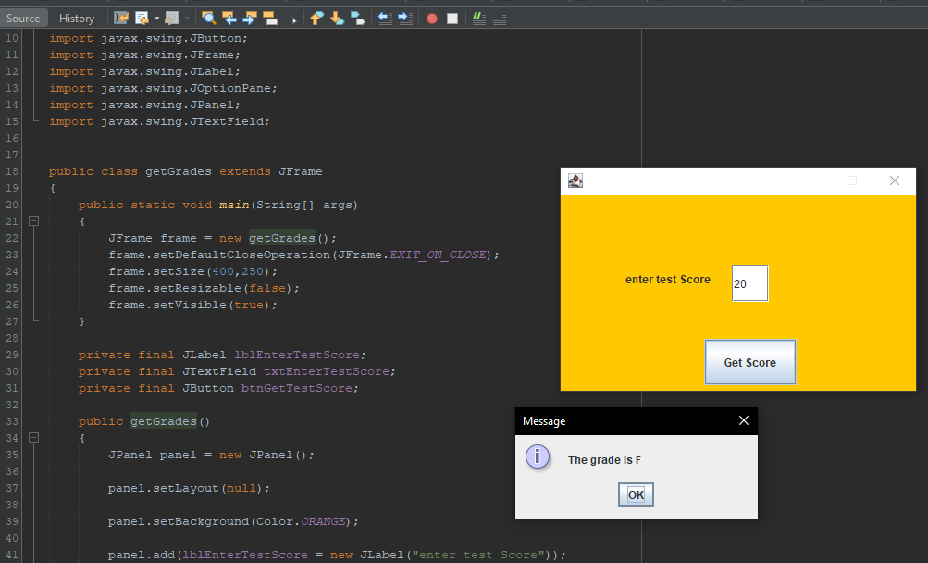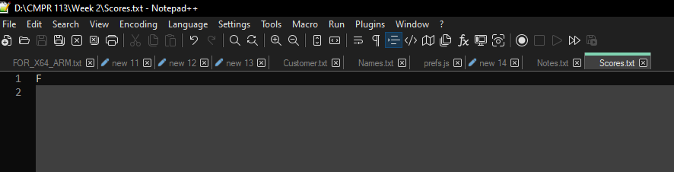

**Sample output**

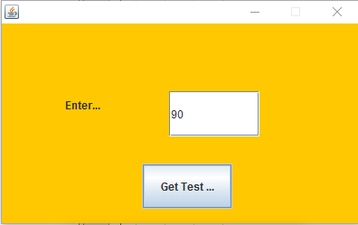

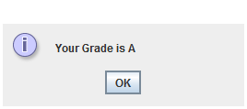

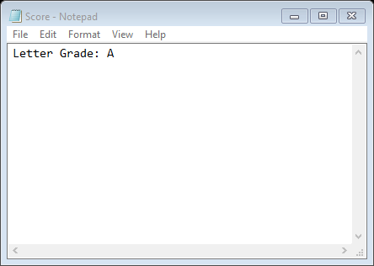

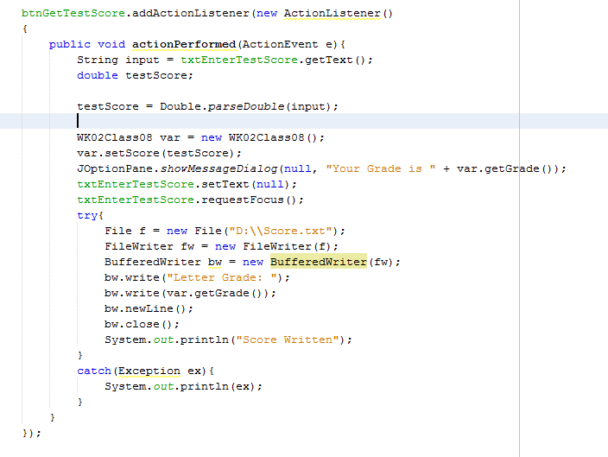

**Challenge Exercise #4:**

For the *car* and *vehicle* classes, create a GUI application that will extend from one class to the other. The functionality will be the same, except you will be creating a GUI app.

**Print screen the running application with code below here**

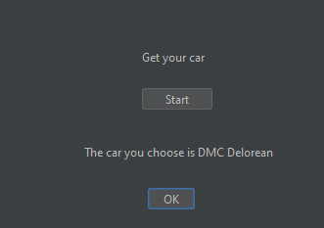

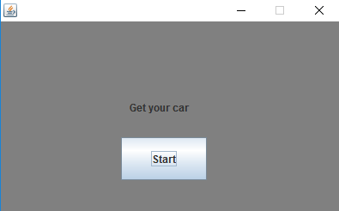

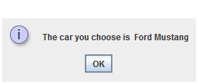

Sample code

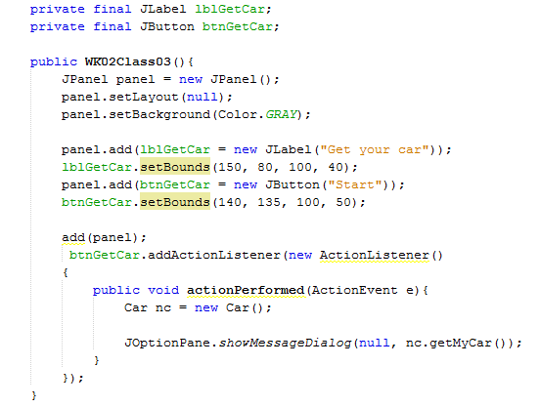

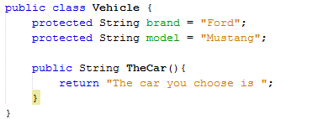

Creating the Car class that extends the Vehicle

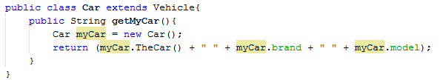

**Challenge Exercise #5:**

For the Employee and Company class created earlier complete the program so the user can input in the Scanner class the following: *City*, *State* and *Zip code*

**Print screen the running application with code below here**

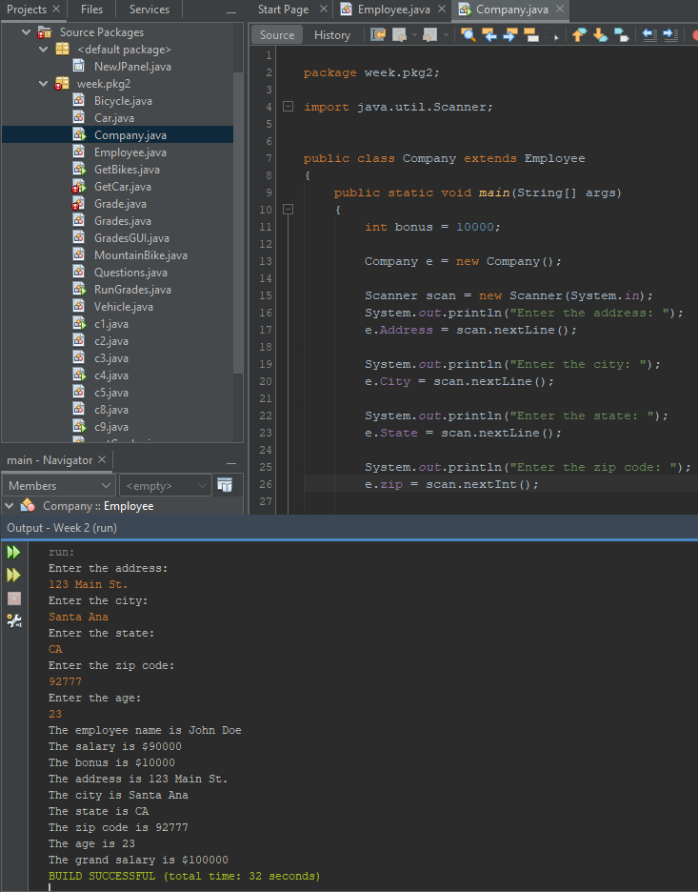

**Sample output**

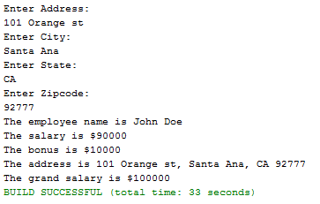

Sample code

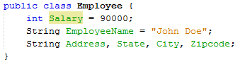

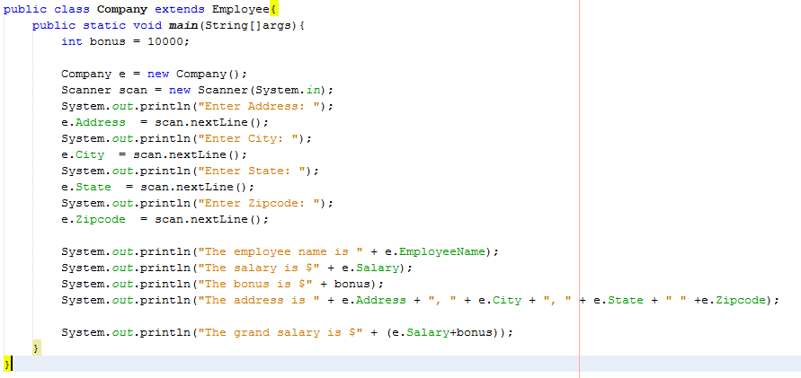

**Submit this document to Module 2 Class Exercise #2**